

Privaatsak X 329, VICTORIA WES, 7070, Tel: 053 6210026, Fstks: 053 6210368
TECHNICAL REPORT

MUNISIPALITEIT MUNICIPALITY U-MAS IPALA | 

UPGRADING OF STREETS IN VICTORIA WEST,
LOXTON & RICHMOND:
PHASE A



Prepared for: Prepared by:
DATE: 04^{t} NOVEMBER 2010

Ubuntu Municipality Private Bag X329 VICTORIA WEST 7070 | Era Engineers (Pty) Ltd PO Box 4344 DURBANVILLE  7551 | 
Tel: 053 621 0026 Tel: 021 975 6200

Ubuntu Municipality  Upgrading of Streets in Victoria West, Richmond & Loxton |  | Technical Report
  ERO
Table of Contents  Item Description |  | Page
1.1 | GENERAL | 'I
1.2 | TERMS OF REFERENCE | 1
2.1 | PROJECT STEERING COMMITTEE (PSC) | 2
2.2 | IMPLEMENTING AGENT AND PROJECT MANAGER | 2
2.2.1 | Implementing Agent | 2
2.2.2 | Project Manager and Design Engineer | 2
. . 3.1 | BRIEF PROJECT DESCRIPTION | 3
(•_-) 3.2 | PROJECT LOCATION | 3
3.3 | DESCRIPTION OF STREETS UNDER INVESTIGATION | 3
3.4 | CLIMATIC CONDITIONS | 4
4.1 | TRAFFIC SURVEYS | 4
5.1 | GEOMETRIC DESIGN | 4
5.1.1 | Typical Road Cross-section | 4
5.12 | Horizontal Alignment | 5
5.1.3 | Vertical Alignment | 5
5.1.4 | Intersections | 5
5.1.5 | Road Safety and Road Signs | 5
_{r} 5.1.6 | Services | 5
--- 6.1 | BACKGROUND | 6
6.2 | ASSESSMENTS AND SURVEYS | 6
6.2.1 | Visual Assessment | 6
6.3 | MATERIALS INVESTIGATION | 6
6.4 | STRUCTURES | 6
6.4.1 | Drainage Structures | 6
7.1 | SCOPE | 7
7.2 | NEW PAVEMENTS | 7
7.3 | ROAD FURNITURE, ROAD SIGNS AND ROAD MARKINGS | 7
8.1 | ACCOMMODATION OF TRAFFIC | 8
82 | PROVISION OF EDGE BEAMS | 8
Ubuntu Municipality  Upgrading of Streets in Victoria West, Richmond & Loxton |  | Technical Report
Item | Description | Page
8.3 | CONSTRUCTION MATERIALS | 8
8.4 | CONSTRUCTION MONITORING | 8
8.5 | EXISTING SERVICES . | 8
9.1 . | CONSTRUCTION COST ESTIMATES | 9
9.2 | FUNDING SOURCES | 9
9.3 | OPERATION AND MAINTENANCE COSTS | 9
9.4 | PROVISIONS FOR OPERATING AND MAINTENANCE COSTS | 9
9.5 | PROPOSED JOB CREATION AND TARGETED PROCUREMENT | 10
9.5.1 | Local Labour | 10
( i
.
\- ' 9.5.2 | Targeted Procurement | 10

APPENDICES
Appendix A: Locality Plan
Appendix B : Appointment Letter
Appendix C: Cross Sections and Layout Drawings Appendix D : Breakdown of Construction Costs

 | ERO 1 ENGENt*.1, ii

Ubuntu Municipality
Upgrading of Streets in Victoria West, Richmond & Loxton Technical Report
1.1 GENERAL
This Technical Report in respect of the proposed upgrading of streets in Victoria West,
Richmond and Loxton is submitted by virtue of the authority conferred by the Ubuntu
Municipality. This is done in accordance with the appointment letter Reference No.
dated 20 October 2010.
In accordance with the ToR, the main objective of the investigation is to determine the most appropriate strategy for the upgrading of the streets in the area under investigation. This report covers the general aspects of the investigation and provides inter alia detail on the existing pavement condition, construction works and cost. The main findings and recommendations are summarised in this report. A project locality plan is presented in Appendix A.
1.2 TERMS OF REFERENCE
The terms of reference the appointment of Ero Engineers (Pty) Ltd [ERO] include inter alia the following:
Planning for upgrading of selected gravel roads in Victoria West, Richmond and Loxton.
Liaison and consultation with communities and various stakeholders in the affected area.
- Preparation and submission of a report embodying preliminary proposals, estimates of cost
and time.
- Compilation of specifications for the construction of the streets identified by the Ubuntu Municipality for implementation.
Basic Planning and Detailed Design of the Project.
Preparation of all Documents necessary to enable Tenders for the Works to be called for. Preparation of any further Plans, Designs and Drawings which may be necessary for the execution of the works.
Advertising of tenders and evaluation thereof.
Contract Administration and Construction Supervision.
Compilation of As-built Drawings and Completion Reports.
Conduct an Environmental Impact Assessment if necessary.
The Appointment Letter is presented in Appendix B.

 | (110 ENGI ERS

Ubuntu Municipality
Upgrading of Streets in Victoria West, Richmond & Loxton Technical Report
2.1 PROJECT STEERING COMMITTEE (PSC)
The PSC will represent all the representatives in the community of Victoria West, Richmond and Loxton. Through the PSC, every community member may therefore make an input in the management of the project. Ubuntu Municipality, in its capacity as the implementing agent, is the principal stakeholder and is also represented on the PSC. The project managers, ERO, are also represented on the PSC. However, their role is to provide technical and managerial advice to the members of the PSG.
2.2 IMPLEMENTING AGENT AND PROJECT MANAGER 2.2.1 Implementing agent : Ubuntu Municipality
Contact person : Mr M Fillis (Municipal Manager)
Address Ubuntu Municipality
Private Bag X329 VICTORIA WEST 7070
Telephone no. (053) 621 0026
Facsimile no. (053) 621 0368
Email mfillisamweb.caza
2.2.2 Project Manager and Design Engineer : Ero Engineers
Contact Person : Mr Kobus Visser
Address Ero Engineers (Pty) Ltd
PO Box 4344
DURBANVILLE
7551
Telephone no. •
(021) 975 6200
Facsimile no.
(021) 975 6400
Email info@ero-engineers.co.za

 | ERO 2

Ubuntu Municipality
 | E RO IENGi 1:4 (F.,..114 | 3

Upgrading of Streets in Victoria West, Richmond & Loxton Tech nicai Report
Other key personnel in the proposed project team are as follows:
Mr 0 Jonker Documentation, Pavement Design
Mr L Kriegler Geometric Design, Stormwater Design
Mr F Henning Construction Monitoring
3.1 BRIEF PROJECT DESCRIPTION
ERO's appointment called for the Upgrading of unpaved streets within Victoria West, Richmond and Loxton. The proposed construction work will inter aria include the following actions:
TABLE 2.1 : SCOPE OF WORKS
Construction Activity | Description
Local residential streets | - Importing material from new borrow pit.  - Construction of stabilised C4 subbase and imported  selected layer.  - Surfacing —80 mm interlocking pavers.
Drainage Improvements | - Concrete V-drains, kerbs, etc.
Road Furniture | - Road signage as required.
Road Markings | - Road markings on completion of road works.

3.2 PROJECT LOCATION
This project lies in Northern Cape Province and includes the towns of Victoria West, Richmond and Loxton.
3.3 DESCRIPTION OF STREETS UNDER INVESTIGATION
The streets under investigation are located within the developed areas. There are major stormwater drainage problems related to these streets as they are not paved and slopes are very steep. Another problem is the fact that these roads were never actually constructed as
Ubuntu Municipality
Upgrading of Streets in Victoria West, Richmond & Loxton Technical Report
roads, rather areas that were cleared and used as roads. Refer to layout plans in Appendix C indicating the streets of concern. No signalised intersection occurs.
3.4 CLIMATIC CONDITIONS

Rainfall Station Longitude
Height
Average Rainfall Average No of Days with rainfall exceeding 10 mm
Beaufort West (00920815) 32°21'23" ; Latitude : 22°34'53" 840 mm above sea level
262 mm per year
6 days / years

t
3.5 TOPOGRAPHY
The towns lie in the typical Karoo region with a flat to undulating topography. 4.1 TRAFFIC SURVEYS
No detailed traffic counts are currently available. The cumulative equivalent design traffic loading will therefore be done by means of estimation from tabulated traffic classes (Draft UTG3 Structural Design of Urban Roads — 1988).
5.1 GEOMETRIC DESIGN
The geometric design of the streets will be done in accordance with the recommended qesign standards. It is therefore envisaged to apply geometric improvements with the intention being to improve the safety of all road users.
5.1.1 Typical Road Cross-section
The proposed new streets consist of single carriageway surfaced streets. The typical cross section varies according to the classification. Detailed cross sections are presented in Appendix C.

 | RO ENG! NF f„115 | 4

Ubuntu Municipality
Upgrading of Streets in Victoria West, Richmond & Loxton Technical Report
Surface drainage will be accommodated on the streets at selected positions. Kerbing will consist of a combination of barrier kerbs and edge beams along the road. Stormwater runoff will be discharged on the surface and no kerb inlets or stormwater pipes will be provided. A lined trapezoidal drain is proposed on one side of the road.
5.1.2 Horizontal Alignment
The local residential streets will be designed for a speed of 50 km/h. The super-elevations on all the horizontal curves will be kept to a two percent reverse camber as far as possible, as a direct result of the urban setting of the road and the low speeds. It is not foreseen that any future improvement to the horizontal alignment would be required.
-} 5.1.3 Vertical Alignment
The streets are situated in a residential area, and the existing vertical alignment will be maintained as far as possible.
The minimum K-values and other vertical design criteria will be according to the normal standards. The presence of existing services in the road reserve will have to be addressed by the vertical alignment.
5.1.4 Intersections
(7⁷ There are no major intersections within the study area.
5.1.5 Road safety and Road Signs
Road signage and road markings will be provided where applicable to improve safety. 5.1.6 Services
All visible services along the entire area must be noted during the visual site investigation. Should major relocation of existing services occur, the horizontal alignment of the road will not deviate from the existing position.
A detailed survey of the existing services will be done in the detail design stage of this project.

 | E RO ENGINEERS 5

Ubuntu Municipality
Upgrading of Streets in Victoria West, Richmond & Loxton Technical Report
6.1 BACKGROUND
A preliminary visual inspection was done during September 2010. A detailed visual inspection will be done during the final design stage.
6.2 ASSESSMENTS AND SURVEYS 6.2.1 Visual Assessment
Pavement
The objective of the detailed visual inspection on the proposed streets is to determine the condition of the existing roads and associated problem areas.
Drainage
Stormwater accommodation, drainage of water on the road surface as well as drainage next to the streets will be inspected.
No ponding of water should be allowed next to the road and should be diverted away from the pavement layers.
6.3 MATERIALS INVESTIGATION
A reputable materials laboratory will be contracted to do a detailed materials investigation on the area under investigation as well as the borrow areas.
• 6.4 STRUCTURES 6.4.1 Drainage Structures
Drainage along the streets will be managed by means of kerbing and concrete trapezoidal drains.

 | E RO lENIN,1„!„1 | 6

Ubuntu Municipality
ERG
;ENCINEE11.5
7

Upgrading of Streets in Victoria West, Richmond & Loxton Technical Report
7.1 SCOPE
The design approach for this project will be based on the following principles:-
To optimise the use of in-situ materials.
To provide an appropriate pavement structure for the selected design life.
The design must be economical and cost effective also in terms of maintenance operations.
7.2 NEW PAVEMENTS
7.2.1 The following pavement structure is considered:
- Utilise of the in-situ pavement material for selected layers and roadbed.
- Import subbase material from borrow pit and surface with 80 mm interlocking pavers.
In keeping with the above, the following preliminary designs are proposed:
Surfacing  ,., | 80 mm Interlocking Pavers (25 MPa)
Subbase  . | 150 mm Stabilised material (C4) compacted to 97% of mod. AASHTO density.
Selected layer | 125 mm Natural gravel (G5) compacted to 95% of mod. AASHTO density.
Roadbed | 125 mm Natural gravel (G8) compacted to 93% of mod. AASHTO density.

7.3 ROAD FURNITURE, ROAD SIGNS AND ROAD MARKINGS
The newly constructed streets need to be furnished with road signs. Road markings along the entire alignment will be constructed. No allowance will be made for the provision of electrical lights adjacent to the streets.
Ubuntu Municipality
Upgrading of Streets in Victoria West, Richmond & Loxton Technical Report
8.1 ACCOMMODATION OF TRAFFIC
The construction of the pavement layers and shoulders will be done in half widths where possible to accommodate traffic (local residents with properties adjacent to the road).
The speed of vehicles alongside actual construction areas must be limited to a maximum of 20 km/h. STOP/GO signs and flagmen shall be employed at the points where construction traffic enters the working area thus creating a potential danger situation for public traffic.
8.2 PROVISION OF EDGE BEAMS
Numerous accesses to properties adjacent to the streets have been observed. Provision has been made in the cost estimate to provide for edge beams and kerbing.
8.3 CONSTRUCTION MATERIALS
The use of in-situ materials will be maximised for the construction of the pavement layers. 8.4 CONSTRUCTION MONITORING
The extent of the work will not warrant full time site staff for construction monitoring. Although it will be finally agreed between the officials of the Ubuntu Municipality and the consulting engineer before commencement of construction, it is recommended that construction monitoring be done at Level 2. This level is in accordance with the duties of the consulting engineer pertaining to construction monitoring as defined in Government Gazette No 31749, 02 January 2009.
8.5 EXISTING SERVICES
Relocation/protection of existing services is anticipated on the project. Provision for this has been made in the cost estimate.
Application for exemption from a full EIA will be made due to the fact that the streets run along the existing disturbed area.

 | E RC) ENGINEE,RS 8

Ubuntu Municipality
ERO,ENGINE._{U.5} 9

Upgrading of Streets in Victoria West, Richmond & Loxton Technical Report
9.1 CONSTRUCTION COST ESTIMATES
It
The total estimated cost to upgrade the local residential streets is detailed below:
Description | Total km | Amount
Major Collector Street | 8.27 | R 36 801 500.00
Access Loop | 2.25 | R 8 691 750.00
Access Street | 0.83 | R 3 087 600.00
Sidewalk brick paved | 8.27 | R 4 217 700.00
Sidewalk sealed | 2.25 | . R 607 500.00
Sidewalk gravel | 0.83 | R 186 750.00
Total cost roadworks |  | R53 592 800.00
Training |  | R200 000.00
Fees (approx 12,5%) |  | R6 750 000.00
Total cost |  | R60 542 800.00
VAT |  | R8 475 992.00
Total estimated cost |  | R69 018 792.00

9.2 FUNDING SOURCES
Municipal Infrastructure Grant (MIG)
r⁻ 9.3 OPERATION AND MAINTENANCE COSTS
No major operational and maintenance costs will be applicable on this road network within the first four years after construction; however should minor defects occur within this time, the Ubuntu Municipality will be responsible to take corrective action.
9.4 PROVISIONS FOR OPERATING AND MAINTENANCE COSTS
9.4.1 The Engineering Department of Ubuntu Municipality will be responsible for all operating and maintenance aspects.
Ubuntu Municipality
Upgrading of Streets in Victoria West, Richmond & Loxton Technical Report
9.4.2 The estimated annual operating and maintenance costs will be included in the tariff structure implemented by the Local Authority.
9.5 PROPOSED JOB CREATION AND TARGETED PROCUREMENT 9.5.1 Local Labour
A condition of tender will be that the Contractor must make use of labour intensive construction methods as far as possible.
It will also be stated in the contract that Contractors shall utilise local labour as much as practically possible and the percentage thereof will be determined by the Ubuntu Municipality in conjunction with the consulting engineers.
9.5.2 Targeted Procurement
The procurement of contracting entities will be done using the targeted procurement procedures. The tender document will be compiled in accordance with Target Procurement Specifications. The tenders will be drawn up in such a way as to ensure access for sub-contactors and local labour.

 |  |  | 01 —1 \

FJJ1VSER DATE

E RO ⁻NGIN
10


Ubuntu Municipality
Upgrading of Streets in Victoria West, Richmond & Loxton Technical Report

APPENDIX A:
RO N,tu
Locality Plan

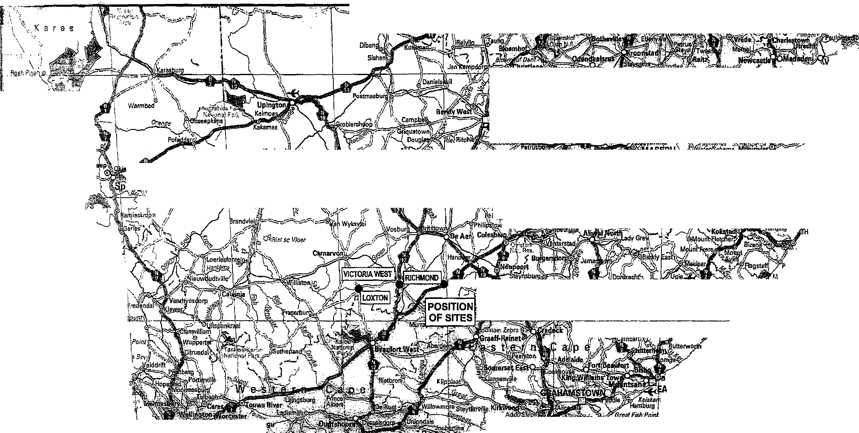

C •

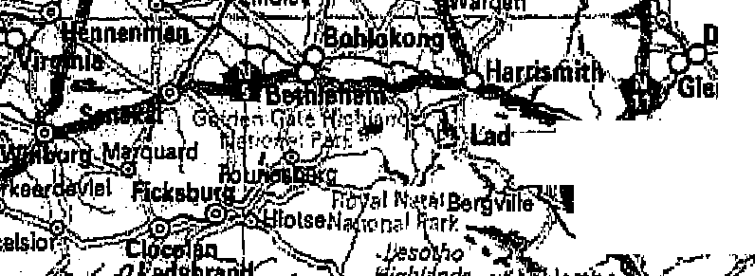
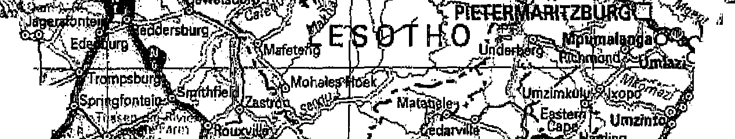


arkas
Sada .
Baboon
S.FIelen
Paternostor,.!:,
VredenhurX'
Saldanha
SpirierM.a 5⁻ay
tangeba
wesa klaRi re flesen.
eacon Bay
ST LONDON
ma Point
Daseen Wan
Hota
,
Vander L-
Vioolsdrif
a rrento ,
7 FreeStat ^{tel}
/ Melia? ⁰,UM
, d
BERLE!? oodder
MON,
Port Nolloth Steinko

- Wedge Point\ 111j.i.kab
N o. r;lit h
EiEsats3f,;"
ok
q^{t11-}4⁸77^{.5.}
_{t}o_{e}

ogserov^{''.1"}.4
I "
¹/0
4w..5;:b—L Eng&
* • eenK ¹⁷W.iEshowec; '
"St t TillskoP

0 „

o 0
ta

_{ongat}
- wn
DURBA

sipifigo
*Amanzimtot
Umlcomaas
Sottrourgh
Sezela
thberdene
)edk: COI WIll Pqrs
Port Shopstone
Ramag vonseo
art Edward
kamnAi :mire qesor.)e
1
Kalkio ind

akho.
Faureamith

Vanderea.

- •
- Gvir•
3,ir4fopteinpunt
Hondedipbaai⁰, „
Sfrandionteinpunt \
Island Point'L\
delbur
1Il_{Or}t SLIJohns
Slik4 Masitre Reserve
1-041eira, Natnra Reserve
Rooduin
Lambettl; Say


Melkb astrend Cof„,,6t,Mon
' at§
itoe;loot.rir

M
4,4r-
. ftrr4,⁴
'

CAPE T •
Hou BayC TAPII_{I}IF,4,4ga7P-T,P
P
-1eXte1tbary.
180401134..Krssrqi
eVece(Xer.umpum)
•
1
rnanado CoprSt Francis
acde


11.4. .491¹¹.- c.^{,n}°
Simon's' own ⁴.,..,;.S.tra,,
dD4 ¹'MM:1.4 Nal:c%,.01FwF
Cape tFpdHope
GanS
•

E RO I ENGINEERS
(Pry) Ltd
Tat + 27 21 975 6200 Fax + 2721 975 6400
E-mail lnfogero-enginears.co.za
Oxford Gate, Block B,54 Oxford Street, Durbanville, 7550,
P.O. Box 4344, DurbanvIlle, 7551
UPGRADING OF STREETS: UBUNTU MUNICIPALITY
File name
N.T.S.
LOCALITY PLAN
Drw No.
ER 1006/01

Ubuntu Municipality
Upgrading of Streets in Victoria West, Richmond & Loxton Technical Report

APPENDIX B:
Appointment Letter


'ty

MUNISIPALITEIT MUNICIPALITY U-MASIPALA | 

UIPUNT11--
Privaatsak X 329, VICTORIA WES, 7070, Tel: 053 6210026, Faks: 053 6210368


VISION
The provision of efficient, sustainable and affordable services to the inhabitants of IThuntu within a safe environment
U VERWYSING:  YOUR REFERENCE: ER1006 |  | ONS VERWYSING:  OUR REFERENCE: MF FILLIS

E-MAIL ADRES: ubuntuvic©wsinetco.za 20 October 2010
ERO Engineers (Pty) Ltd P.O. Box 4344
Durbanville
7551
ATTENTION Mr FJJ Visser
LETTER OF APPOINTMENT: CONSULTING ENGINEER: UPGRADING OF STREETS IN VICTORIA WEST, RICHMOND AND LOXTON
We hereby confirm that ERO Engineers (Pty) Ltd has been appointed to perform the civil engineering services of the abovementioned project.
The appointment is based on the following attached agreement:
- CESA Standard Form of Agreement for Consulting Services.
- ECSA Guideline Scope of Services and Tariff of Fees.
The scope of works includes provision professional civil engineering services in connection with the upgrading of unsurfaced streets in the towns of Victoria West, Richmond and Loxton under the authority of Ubuntu Municipality..
The council resolution number is and the IDP number is
We trust you will find the above in order.
Yours faithfully.
MF FILLIS Municipal Manager

Ubuntu Municipality
4⁷⁴.IN
Upgrading of Streets in Victoria West, Richmond & Loxton Technical Report
APPENDIX C:
Cross Sections and
Layout Drawings

