NOTAS / NOTES
LEGEN DE
Diatila
li boUndaties
Munto1pOlty botsndartas
Road
 |  | Ranway
DOW | II g | MONO | KRIM
CM | II g | AMEN:on:NT | SM.
MOW tiniXREK 1
P1.17 MED I

wen
UBUN1U MUNICIPAUTY
S'InecsaE3II-IS
De⁻vioprriciat(Pty)Ltd
Porlook SAto 141
Non** / Md. too V5FAI
MO 1.1R114X11
Rs, 4
⁴1... MHO
% 111312746 4E04
T⁴. /f.. ((44) Bum
.
: InblIrkl:Welue E-nlat loliodloolkoot
Ni
DIENA / gERMICE
UBUNTU MUNICIPAUTY
STORM %WIER MASTER PLAN
7TREL / 7171X
LOCAUTY PLAN
I TORENN0 on. / 06#1,1C NCO
SKI985/1

_ .  VAX / SCAM 11 NO KO | CO M  _{mom} | -  E: FOS
LEER NR. / Ftt MX
^{WAN} I AL 2009 _ . DA'r

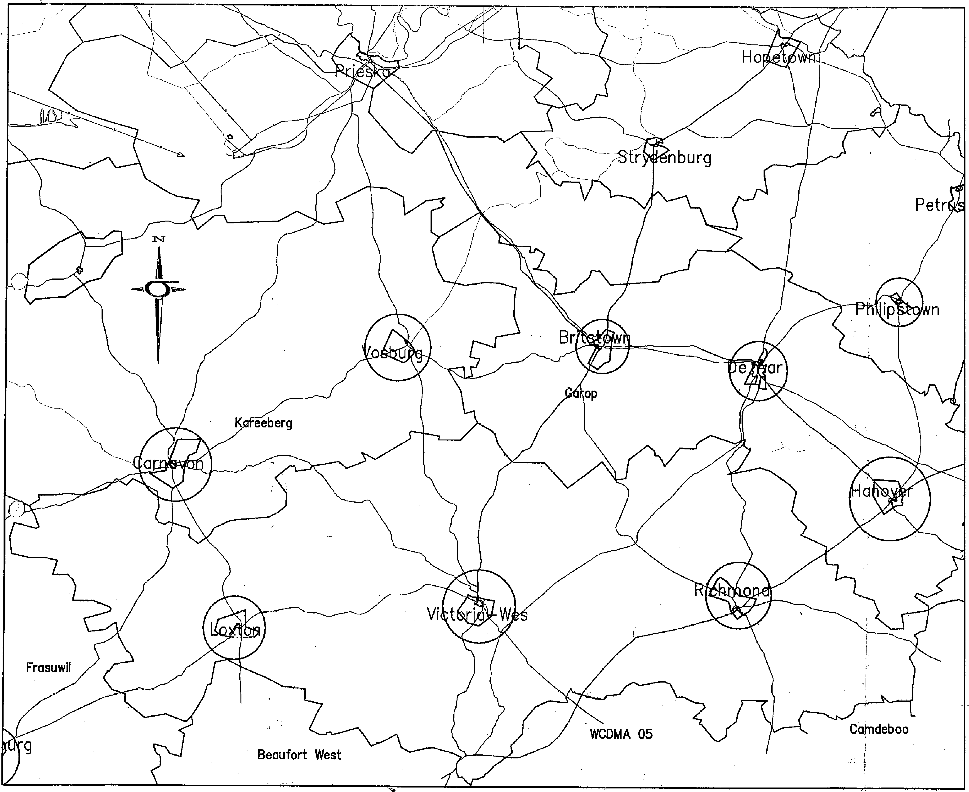
NOTAS / NOTES
DATUM | lig | IMMO | HANOT.
DATE | lig | ALENOWENT | SEN.
AFDP0.15 INTGEREK
, PRINT ISSUED

DelE / SEDVDE
UBUNTU MUNICIPAUTY
STORM WATER MASTER PLAN
WAAL / SCALE I WES | CEIDIN DRAIN | L IEIS
LEER Fa / FIE 140. | OtilIEW COOED-
DATLIM  2DO  DATE .ILD | 1416ESEN.  CHMED

IWO
261. (05351624
FUMIMEO
- blkaltOdallunee
1110. / DILE
LOCALITY PLAN - IACTORIA IEST
KUM / CLIENT
UBUNTU MUNICIPALITY
."-TIPs3E3
DeV01013112ent(Pty)litti
/¹¹¹.0.
MEW* P.¹¹.1t lutlz 12d
1¹¹4o144* / Aim% Bei Mill
¹23.101.1
11¹30¹2
Td Ma) 3211⁻222
E-not olkwderilknet
mi. %No No.
SK1985/2
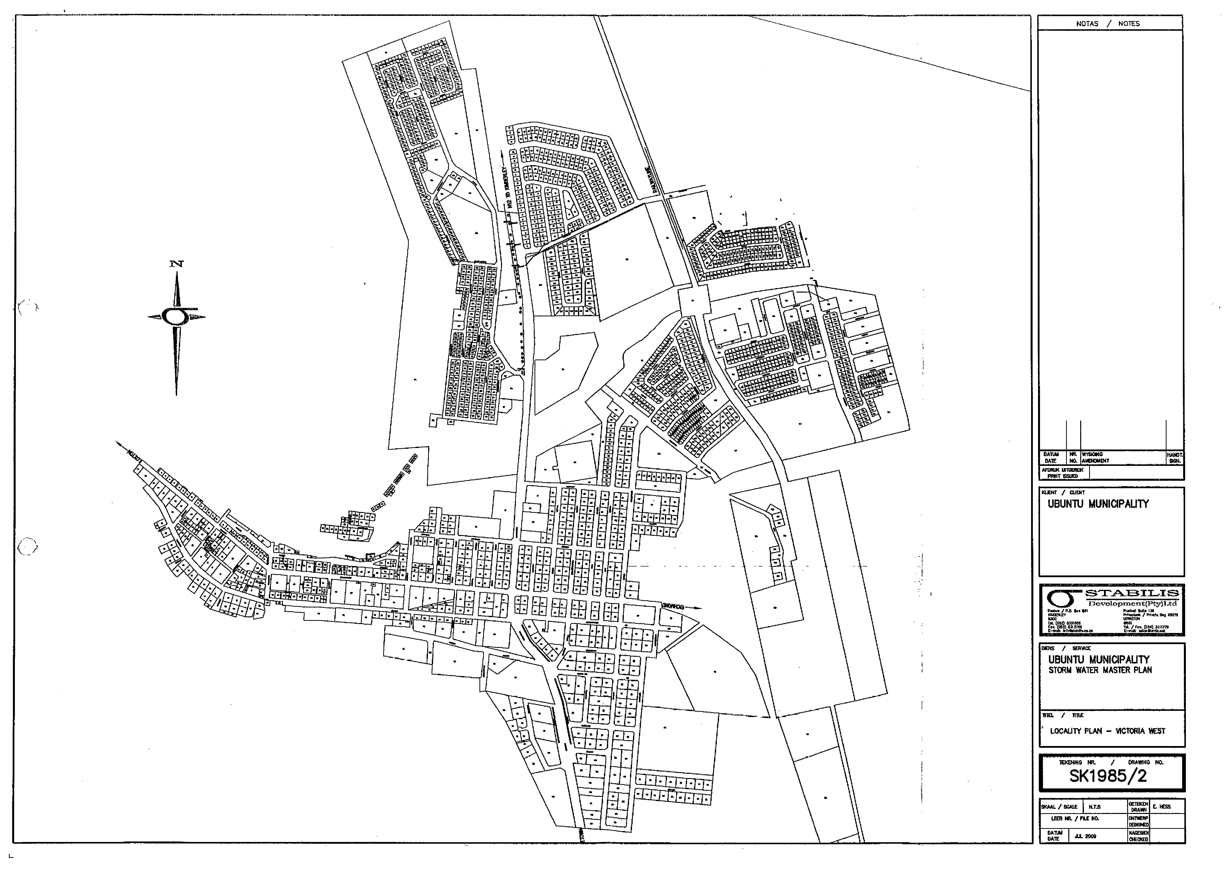
NOTAS / NOTES
D.411A4 | kA | MGM | HOEYL
DATE | kA | ANENOMENT | N.
MOM UILOLREK
ORM ISOLEO

ELMS / SERVICE
UBUNTIJ MUNICIPALITY
STORM WATER MASTER PLAN
¹¹¹EL / lITLE
LOCALITY PLAN - RICHMOND
SKOL / VALE WES | SiTICWES  MOW | E HESS
LEER HR. / FIE NO.
WOW | HAMM
D_{ATE} ;X MG | cHorxm

NISEFIXf
^{9W}kisqa.va
WENT / JEMT
UBUNIU MUNICIPALITY
Cy .."1".."..31.
rieveloprrierit(Ptyg_td
PA1 gas 01, Z:ateriZeki 134 kEtl
POI
14 Ire..Z.111⁻49 C-reciE IrSmilkel*.ort
SKI 985/3
I TOCENISLO NIL / ORMONO
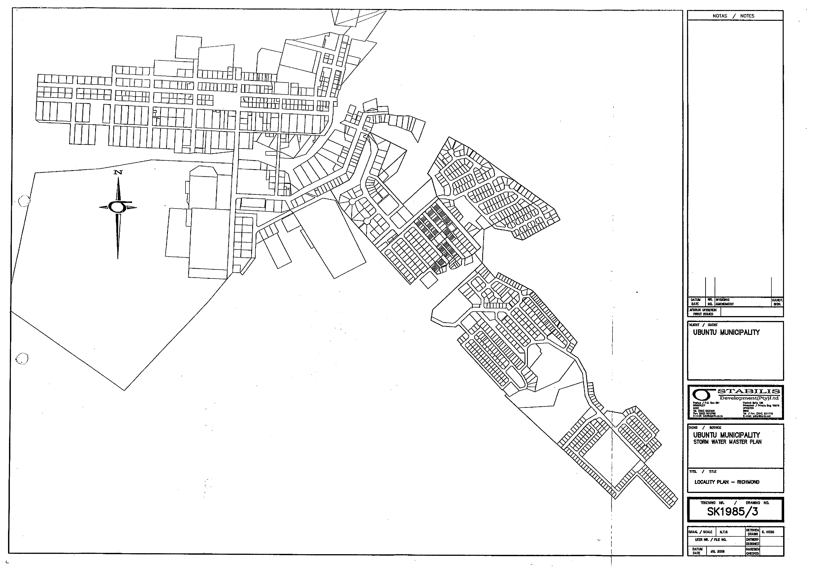
0
NOTAS / NOTES
•..DAUSI OM | [g g | WOOING AMOMENT | HAW,  VON.
Amax imam I
PRWT NEM I

PENS / SERVICE
UBUN1U MUNICIPALITY
STORM WAlER MASTER PLAN
TtTEL / VTLE
LOCALNY PLAN - =TON
SEA& / SCALE fLES | SETOEN  MAIN | E. FESS
LOIN M. / FIE NO. | ONTNERP  WOOED
DATUM I  -SATE JUL 2001 | NMESEN  CHEESED

MINT / WENT
UBUNTU MUNICIPALITY
Davelogrnent(Pty)Ltcl
Padam / PA. ⁷¹⁷⁷ OH P7.1771 WM 103
111170¹0.17 0,0011003 / Mehl Ow OEM
1307 ¹.1⁷1007311
101. (0131 MUM
°, r73. (037] 3311771
Ewnrgar13111173737 T. E-00U ⁴01•1143117704.
I TUNING Wt._ / ORAWNO NO.
SK1985/4
