Having an understanding of the current situation allows the most important aspect of the plan to be addressed: service level targets. This section sets out what services will be provided to consumers, both in terms of level of service and quality of service. Before going into the tables themselves, some explanatory text is given dealing with types of services and the importance of formulating a service level policy.
The vision and mission of the IDP should drive this part of the planning process. For example, the vision of the IDP could be, amongst other things, to ensure that all citizens have access to at least a basic level of service within five years.
The targets set in this section must be compatible with the IDP.
The proposed programme, as defined by the service level and service quality goals, can only be done with reference to the full integrated planning process, considering socio-economic, water resource, environmental, infrastructure, management and financial constraints. This implies that a number of scenarios will have to be tested before the most appropriate one can be decided upon.
Types of services
The concept of service levels relates to the options which consumers can be given with regard to the convenience of the service and hence the amount of water, which they will consume, and the associated wastewater they will generate.
There are ranges of different service types, which can be provided. These are clarified below according to the types reported in the tables.
None or inadequate
This refers to the number of consumer units (or households) that do not have access to basic water supply or sanitation.
Basic water supply comprises:
a) The provision of appropriate education in respect of effective water use; and
b) A minimum quantity of potable water of 25 litres per person per day –
- At a minimum flow rate of not less than 10 litres per minute;
- Within 200 meters of a household; and
- With an effectiveness of not more than 7 days interruption supply to any consumer per year.
Basic sanitation comprises:
a) The provision of appropriate health and hygiene education; and
b) A toilet which is safe, reliable, environmentally sound, easy to keep clean, provides privacy and protection against the weather, well ventilated, keeps smells to a minimum and prevents the entry and exit of flies and other disease- carrying pests.
(Source: Compulsory national standards in terms of Sections 9(1) and measures to conserve water in terms of 73(1)(j) of the Water Services Act.)

Water service levels
Communal water supply
See ‘basic water supply’ explained above.

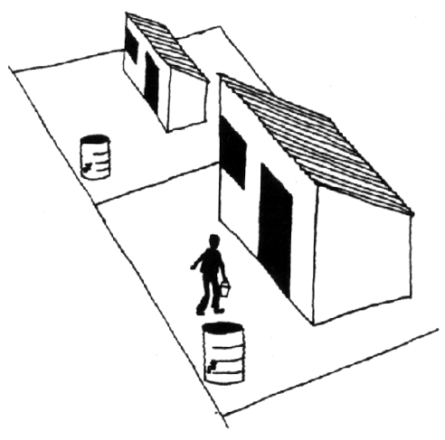
Controlled volume supply
E.g. Yard Tanks. Each house is provided with a tank, which holds about 200 litres. The tank gets filled up once a day. This type of service is often referred to as an intermediate level of supply.
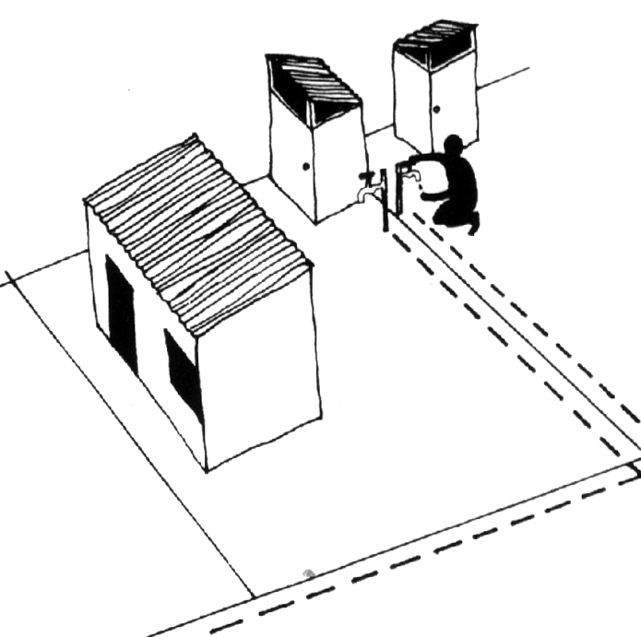
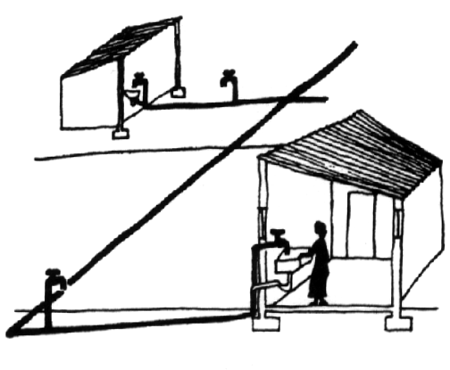
Uncontrolled volume supply
There are generally two types: either the tap stands outside the house on its own or on the wall of an outside toilet (yard tap) or water is piped into the house to take water to taps in the kitchen, bathroom, toilet etc.
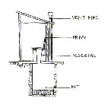
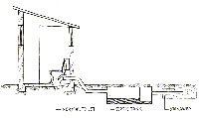
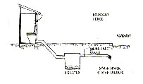
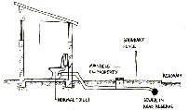
Sanitation
Consumer installations: Dry
See basic sanitation supply explained above.
Ventilated Pit: A basic pit latrine structurally reinforced without preventing water seepage into surrounding soil, a slab that seals the edges of the pit and a screened air pipe that vents smells from the pit into the air above the privy. The concrete slab over the pit is not standard requirement for all VIP toilets, but necessary under certain geotechnical conditions and it must comply with ground water protocol.
Eco San option: one of a range of sanitation options that covert the waste products into re-usable agricultural soil conditioners of fertilizers on-site (usually without water use)

Consumer installations: Wet (septic tanks)
Water is flushed into a digester where certain bacteria and other organisms breakdown the solids. Digester effluent flows into the soak away, then the ground and it must be ensured that the soak away does not cause pollution of ground water. There can be a build up of sludge in the digester that has to be pumped out occasionally.
In some cases the effluent from the septic tank is discharged into the bulk sewer network, which leads to a sewage treatment plant or oxidation ponds.
Discharge to wastewater treatment works
Here there are generally two types: intermediate (e.g. aqua privy with solids free sewer which is similar to a septic tank, but instead of a soak away the digester effluent flows into a pipe which connects to a small sewer in the road reserve).
Full waterborne refers to the situation where a flushing toilet is used; the wastewater flows to a sewer on the site, then to sewers on the street. Effluent discharged from sewage treatment works must meet national effluent discharge quality standards in order to avoid polluting the water resources.

References for more detailed information on sanitation technology options
- If applicable describe
- Average capital and O&M costs of the different technology choices

Provide references for suitable guidelines on technical options

Key issues to be taken into account when choosing an appropriate Sanitation Service Level

O&M arrangements
- Desludging of septic tanks
- Pit emptying service
- Capacity of the bulk sewer network and sewage treatment works
- Availability of adequate water for waterborne sanitation
- Availability of budgets for O&M

Service level policy
The key issue in preparing a service level policy is that higher than basic services should be provided only where households can afford these levels of service, due to the necessity of recovering the increased capital and operating and maintenance costs. While politically difficult, this is likely to be the only way in which sustainable services can be provided in the long term. There are numerous examples of unaffordable service levels being provided with catastrophic results for both households and municipalities.

Existing service levels
Having an understanding of the types of services available, the WSA should assign existing services to these different levels and report the figures in the current columns of the tables. Considerable work will need to be done in integrating information from the different areas that comprise the new water services authorities.

Service level targets
Service level targets (set within the constraints of the service level policy) can be set as follows:
- New consumer units - This refers to new units that will need to be provided as a result of natural population increase or migration to the area.
- Current backlogs - This refers to those households that are currently not adequately served, for example those having a supply less than RDP standards.
- Upgrading - This refers to those households who currently have adequate services but who are to be upgraded to a higher level.
The figures need to be consolidated and translated into targets per year for the number of consumer units, which will have access to each level of service category and recorded in the tables in Error: Reference source not found.
If for any reason basic services cannot be extended to all consumer units within 5 years, reasons need to be stated in the text as to why this is so.

Service level coverage – “quantity”
The current situation needs to be completed for the settlement types i.e. urban and rural (dense, village, scattered and farmland) and consolidated according to the tables below. Separate tables are given for each category of user. Once the scenario has been chosen, the targets need to be reported in the columns from year 1 to year 5. By year 5, there should be no consumer units that have a level of supply that is “none or inadequate”. If this cannot be achieved, reasons for this must be stated in the text.

  - Residential Consumer Units

All consumers should have access to at least a basic level of supply (2) by or in year 5. If this is not possible, reasons for this should be included in the text component that accompanies the tables.

    - Situation Assessment (Residential Consumer Units)

      - Residential Consumer Units for Water and Sanitation: Level of services

 |  | Above RDP | Below RDP |  | Total below
Quantity | Def | 25l / c / d | 0 – 10l/c/ d
Quantity | Pop | 7329 | 724 |  | 724
Quantity | % | 91,0 | 9,0 |  | 9,0
Distance | Def | 0 - 200 | 200 - 500 | >500
Distance | Pop | 8053
Distance | % | 100
Availability | Def | 98% of time | <98%
Availability | Pop | 7329 | 724 |  | 724
Availability | % | 91,0 | 9,0 |  | 9,0
Flow/ Assurance | Def | 10l / min | <10l / min
Flow/ Assurance | Pop | 7329 | 724 |  | 724
Flow/ Assurance | % | 91,0 | 9,0 |  | 9,0
Quality | Def
Quality | Pop | 8053
Quality | % | 100

      - Residential Consumer Units for Water

- Provide information regarding consumer units for water as indicated below:

No. Consumer units with: | Urban | Rural: Dense | Rural: Village | Rural: Scattered | Rural: Farmland
- None or inadequate
- Communal water supply |  |  | 0
- Controlled volume supply |  |  | 0
- Uncontrolled volume supply: yard tap or house connection |  |  | 2120
- Total Served (2+3+4) |  |  | 2120
- Total (1+5) |  |  | 2120

      - Residential Consumer Units for Sanitation

- Provide information regarding consumer units for sanitation as indicated below:

No. Consumer units with: | Urban | Rural: Dense | Rural: Village | Rural: Scattered | Rural: Farmland
- None or inadequate: Below RDP: Pit |  |  | 22
- None or inadequate: Below RDP: Bucket |  |  | 605
- Consumer installations: On Site dry or equivalent, including VIP toilets, USD, composting system
- Consumer installations: Wet (Septic tank, digester or tanker desludge or effluent discharge to an oxidation pond etc.) |  |  | 1493
- Discharge to sewer treatment works (intermediate or full waterborne) |  |  | 0
- Total Served (3+4+5) |  |  | 1493
- Total (1+2+6) |  |  | 2120

2.1.1.4 Grey Water Management
- Provide information regarding Grey Water Management in dense informal settlement areas that are provided with dry sanitation systems.

- Ubuntu Municipality does not provide dry sanitation systems at all and does not have any grey water problems. However, investigations will be done to re-use grey water in future.

2.1.1.5 Pit emptying and sludge disposal
- Plan for pit emptying and sludge disposal when VIP toilets are installed in dense settlements without access to land for relocating the toilet superstructure.

- Ubuntu Municipality will provide for pit emptying or desludging of dry sanitation systems.
    - Future Trends And Goals (Residential Consumer Units)

- Provide statistics and comments on the future trends and goals for the following

      - Residential Consumer Units for Water & Sanitation: Level of service

      - Residential Consumer Units for Water

Water
 | 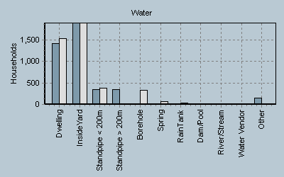
  Households | 2001 | 1996
  Dwelling | 1410 | 1527
  Inside Yard | 1893 | 1885
  Community Stand | 344 | 378
  Community stand over 200m | 343 | -
  Borehole | 12 | 336
  Spring | 0 | 66
  Rain Tank | 2 | 27
  Dam/Pool/Stagnant Water | 3 | -
  River/Stream | 0 | -
  Water Vendor | 4 | -
  Other | 153 | 3

      - Residential Consumer Units for Sanitation

Sanitation
 | 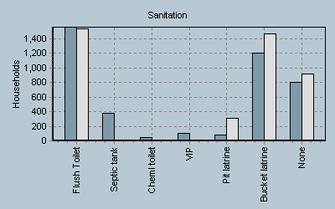
  Households | 2001 | 1996
  Flush Toilet | 1556 | 1538
  Flush septic tank | 373 | -
  Chemical toilet | 48 | -
  VIP | 107 | -
  Pit latrine | 83 | 311
  Bucket latrine | 1200 | 1467
  None | 797 | 910

      - Grey Water Management
- No grey water is currently used.

      - Pit emptying and sludge disposal

- No VIP toilets are used.

      - Types of sanitation technology options

- Only water borne toilets are provided.

      - 2010 target for basic sanitation

- Ubuntu Municipality will ensure that all households with sanitation services below RDP standard will receive such services, at least up till RDP standard. The farms remains problematic and the municipality will, with the assistance of the Pixley ka Seme District Municipality and DWAF identify the backlogs and plan to eradicate any backlogs that may exist.

    - Strategic Gap Analysis (Residential Consumer Units)

- Comment on the evaluation of statistics provided for all elements discussed under Future Trends and Goals.

- Indicate Implementation Problems and Gaps on the specific elements.

- Selection of sanitation technology

- The council of Ubuntu Municipality took a policy decision to only provide waterborne sanitation to communities.

- The Ubuntu Municipal Area has no surface water and only uses underground/borehole water. The yield of the boreholes are however not sufficient to sustain this option in the future, especially as services needs to be extended to cover those areas not yet serviced.

- This necessitates the municipality to look at alternative ways and new technologies to provide sanitation services and the re-use of water.

- The Rapid Reactor Activated Sludge System seems to be one option to provide waterborne systems as 90% of the effluent from the clarifier can be re-used for flushing toilets. This system needs further research and investigation as it can benefit most local municipalities, especially those with limited under ground water resources.

- Operation and maintenance of sanitation infrastructure

- Operations and maintenance of sanitation infrastructure and the refurbishment of such infrastructure remains a high priority for the Ubuntu Municipality, although not always properly budgeted for and maintained.

- Ubuntu Municipality will budget and seek funds for the refurbishment and maintenance of all sanitation infrastructures.

    - Implementation Strategies (Residential Consumer Units)

- For Residential Consumer Units discuss the situations assessment and Future trends and goals under the following:

- Also provide strategies to address the gaps in relation to 1-5.
- Provision for O&M of sanitation systems
- Provision for health and hygiene education
- Sanitation
- Community involvement in the selection of sanitation technology option
- O&M requirements and tariff structure
- Groundwater pollution risks in the case of VIP toilets

1. Basic Services

- The council of Ubuntu Municipality took a policy decision to only provide waterborne sanitation to communities.

- The Ubuntu Municipality will have to look at innovative alternative ways and new technologies to provide sanitation services in future.

- This may result into the re-use of grey water and purified effluent.

- Higher Level, associated services and economic growth

- The council of Ubuntu Municipality already took a policy decision to only provide waterborne sanitation to communities, which are referred to as higher levels of services.

- The majority of the people in the Ubuntu Municipal Area are poor and will be dependent on the one or other form of government grant. It is also clear that they will struggle to make ends meet and will be in no position to afford high municipal bills.

- Approximately 22, 64% or 2 596 people out of 11 465 between the ages of 15-64
are unemployed. This will have a negative impact on payment levels for services.

- Effective water resource management

- Ubuntu Municipality will have to plan carefully according to available water
and water resources and implement strict and effective water
resource management systems and restrictions.

- Social and Environmental (health) issues

- Ubuntu Municipality will have to do environmental impact assessments
and determine social and environmental health effects when planning for
higher levels of services, or associated services and economic growth.

  - Ubuntu Municipality will have to continue with the provision of environmental health and hygiene education. These programmes will also have to include awareness on the re-use of grey water and purified effluent

- Effective Management

- Ubuntu Municipality will have to plan carefully and implement stringent
control mechanisms and procedures to ensure that water users adhere to agreed
water levels and achieve desired water demand managements targets.

- The strategy would be to plan and develop measures for water restrictions, re-use of grey water and effluent, demand management and to ensure that water users adhere to their limits through strict and effective management systems and procedures.

Public Institutions and ‘dry’ industries

    - Situation Assessment (Public Institutions and ‘dry’ industries)

      - Public Institutions and ‘dry’ industries

The existing situation and targets for industrial consumers should also be distinguished according to urban and rural. Public institutions and ‘dry’ industries have similar consumer types to residential consumer units and can be assessed in a similar way.

- Provide information requested in the table below:
Public amenities consumer types | Type | No. Of consumer units | No. Of consumer units with access to:
Public amenities consumer types | Type | No. Of consumer units | None or inadequate | Communal supply | Controlled volume supply | Uncontrolled volume supply
Police Stations | Urban
Police Stations | Rural | 3 |  |  |  | 3
Magistrate offices | Urban | 2 |  |  |  | 2
Magistrate offices | Rural
Businesses | Urban | 73 |  |  |  | 73
Businesses | Rural
“Dry” Industries | Urban | 0
“Dry” Industries | Rural
Office Buildings | Urban
Office Buildings | Rural
Garages | Urban | 12 |  |  |  | 12
Garages | Rural
Prisons | Urban | 2 |  |  |  | 2
Prisons | Rural
Schools | Urban | 12 |  |  |  | 12
Schools | Rural
Hospitals | Urban | 2 |  |  |  | 2
Hospitals | Rural
Clinics | Urban | 3 |  |  |  | 3
Clinics | Rural
Crèches | Urban | 5 |  |  |  | 5
Crèches | Rural
Other (Specify) | Urban | 38 |  |  |  | 38
Other (Specify) | Rural
Total | Urban
Total | Rural

Resources available to perform function:
- Complete the following structure:

 | Yes | No | N/A | Comment
Is there budget? | Y
Are there By-laws? | Y |  |  | Must be reviewed
Is there infrastructure? | Y
Personnel available? | Y

    - Future Trends And Goals (Public Institutions and ‘dry’ industries)

- Provide statistics and comments on the future trends and goals for the following

      - Public Institutions and ‘dry’ industries

- All public institutions have sufficient water. Ubuntu Municipality will,
however, investigate the possibility to introduce Rapid Reactor Activated
Sludge Systems at public institutions and dry industries as this offer a solution
to water conservation and demand management because of the fact that water
is scarce in the Karoo.

- Ubuntu Municipality will engage and have discussions with all the relevant
sector departments as part of future planning processes in this regard.

    - Strategic Gap Analysis (Public Institutions and ‘dry’ industries)

- Comment on the evaluation of statistics provided for all elements discussed under Future Trends and Goals.
- Indicate Implementation Problems and Gaps on the specific elements.

- The Rapid Reactor Activated Sludge Systems is a new system, and, although
approved by DWAF as an alternative to current systems used by municipalities,
is not well known.

- The installation costs will have to be investigated as dual water net works will have
to be provided at public institutions and dry industries where the system is to
be implemented.

- Ubuntu Municipality will seek funds to do a feasibility study to determine the costs
of the Rapid Reactor System vs. current systems used by the municipality, as well
as the long term benefits of the system and the possible impacts on the
current water sources and the environment.

    - Implementation Strategies (Public Institutions and ‘dry’ industries)

- For Public institutions and ‘dry’ industries discuss the situations assessment and Future trends and goals under the following:

- Basic Services
- Higher Level, associated services and economic growth
- Effective water resource management
- Social and Environmental (health) issues
- Effective Management

- Also provide strategies to address the gaps in relation to 1-5.

1. Basic Services

      - The Ubuntu Municipality will have to look at innovative alternative ways and new technologies for the provision of basic services to public institutions and ‘dry’ industries .

      - This may result in the re-use of grey water and purified effluent.

    - Higher Level, associated services and economic growth

      - As stated above, the Ubuntu Municipality will have to look at innovative alternative ways and new technologies for the provision of higher level, associated services and economic growth to public institutions and ‘dry’ industries, as water is a scarce resource in the municipal area and current sources will not be able to provide in higher, increased demands.

    - Effective water resource management

      - Ubuntu Municipality will have to plan carefully according to available water
and water resources, allocate allotted amounts of water to public institutions
and ‘dry’ industries, as water is a scarce resource, and implement strict
and effective water resource management systems to ensure compliance to
the allocated lots.

    - Social and Environmental (health) issues

      - Ubuntu Municipality will have to do environmental impact assessments
and determine social and environmental health effects when planning for
higher levels of services or associated services and economic growth for
public institutions and ‘dry’ industries.

    - Effective Management

      - Ubuntu Municipality will have to plan carefully and implement stringent
control mechanisms and procedures to ensure water users adhere to agreed
water levels and achieve desired water demand managements targets.

- The strategy would be to plan and develop measures for water restrictions, re-use of grey water and effluent, demand management and to ensure that public institutions and ‘dry’ industries adhere to their limits through strict and effective management systems and procedures.
  - Wet Industries

    - Situation Assessment (Wet industries)

      - Wet Industries: Urban and Rural

Wet industries will generally have full access to water supply but may have a wide range of water use and water quality requirements. This information takes a closer look at major industrial water usage and especially industrial water quality required, which could also be slightly impure water but still fit for industrial use. List all the ‘wet’ industries and record their individual water use, pressure and water quality requirements.

- Provide information requested in the table below:

List Individual “wet Industries | Monthly Water use (kl) | Pressure (kPa) | Water Quality |  |  | Reliability (inadequate adequate, special treatment) | Billing system (none flat rate metered)
List Individual “wet Industries | Monthly Water use (kl) | Pressure (kPa) | Raw | Filtered | Chlorinated | Fully Treated
Karoo Delights | 100kl |  | 100kl |  |  |  | None
Victoria West Abbatoir | 100kl |  |  |  |  | 100
Total | 200kl |  |  |  |  | 100

Resources available to perform function:
- Complete the following structure:

 | Yes | No | N/A | Comment
Is there budget? |  |  | N/A
Are there By-laws? |  | No
Is there infrastructure? |  |  | N/A
Personnel available? |  |  | N/A

    - Future Trends And Goals (Wet industries)

- Provide statistics and comments on the future trends and goals for the following

      - Wet Industries: Urban and rural

- There is a plant at Noblesfontein where ±800kl mineral water is abstracted monthly, bottled and sold to businesses and the public. There are plans to increase the capacity of the plant and to bottle more water.

    - Strategic Gap Analysis (Wet industries)

- Comment on the evaluation of statistics provided for all elements discussed under Future Trends and Goals.
- Indicate Implementation Problems and Gaps on the specific elements.

- Ubuntu Municipality is currently not involved or render no services to the Wet industries.

- However, as soon as the Abattoir is upgraded to slaughter 1 000 sheep per day the municipality will have to provide the necessary services.

- Ubuntu Muninicipality will also get involve when abstraction is increased and the private developers do not comply with government regulations regarding permits and allowed abstractions (water mining).

    - Implementation Strategies (Wet industries)

- For Wet Industries discuss the situations assessment and Future trends and goals under the following:

- Basic Services
- Higher Level, associated services and economic growth
- Effective water resource management
- Social and Environmental (health) issues
- Effective Management

- Also provide strategies to address the gaps in relation to 1-5.

- Ubuntu Municipality is currently not involved or render no services to the Wet industry.

- Ubuntu Muninicipality will get involve when abstraction is increased and the private developers do not comply with government regulations regarding permits and allowed abstractions (water mining).
  - ‘Raw’ Water Consumers

    - Situation Assessment (‘Raw’ Water Consumers)

      - ‘Raw’ Water Consumers: Urban and Rural

This category comprises animal husbandry, SPCA, feed lots, chicken houses, green houses, vegetable gardens, intensive agriculture, parks and sport facilities.
It may be that intensive agricultural industries make use of municipal water supply or share in the water resource and bulk supply infrastructure. If so, characterise their water use in the following table.

- Provide information requested in the table below:

‘Raw’ Water Consumer | Monthly Water use (kl) | Pressure (kPa) | Water Quality |  |  | Tariff (R/kl) | Reliability (inadequate adequate, special treatment) | Billing system (none flat rate metered)
‘Raw’ Water Consumer | Monthly Water use (kl) | Pressure (kPa) | Raw | Filtered | Other | Tariff (R/kl) | Reliability (inadequate adequate, special treatment) | Billing system (none flat rate metered)
 | N/A
Total

    - Future Trends And Goals (‘Raw’ Water Consumers)

- Provide statistics and comments on the future trends and goals for the following

      - ‘Raw’ Water Consumers: Urban and Rural

- There are currently no raw water consumers in the Ubuntu Municipal Area.

    - Strategic Gap Analysis (‘Raw’ Water Consumers)

- Comment on the evaluation of statistics provided for all elements discussed under Future Trends and Goals.
- Indicate Implementation Problems and Gaps on the specific elements.

- There are currently no raw water consumers in the Ubuntu Municipal Area.

    - Implementation Strategies (‘Raw’ Water Consumers)

- For ‘Raw’ Water Consumers discuss the situations assessment and Future trends and goals under the following:

- Basic Services
- Higher Level, associated services and economic growth
- Effective water resource management
- Social and Environmental (health) issues
- Effective Management

- Also provide strategies to address the gaps in relation to 1-5.

- There are currently no raw water consumers in the Ubuntu Municipal Area.

  - Industrial Consumer Units

    - Situation Assessment (Industrial Consumer Units)

      - Industrial Consumer Units for Sanitation: Urban and Rural

The existing situation and targets for industrial consumers should also be distinguished according to urban and rural. Industrial consumers typically discharge directly to treatment works and do not have intermediate options, as is the case for residential consumers.

- Provide information requested in the table below:

Industry | Number of service units | Monthly waste water (kl) | Monthly Sewage (kl) | Washing leaches through storm water system (kl) | Total Treated effluent (kl) | Total Untreated effluent (kl) | Total Return flow to river system (kl)
Total

    - Future Trends And Goals (Industrial Consumer Units)

- Provide statistics and comments on the future trends and goals for the following

      - Industrial consumer units for sanitation: Urban and Rural

- There are currently no industrial consumers units in the Ubuntu Municipal Area.

    - Strategic Gap Analysis (Industrial Consumer Units)

- Comment on the evaluation of statistics provided for all elements discussed under Future Trends and Goals.
- Indicate Implementation Problems and Gaps on the specific elements.

- There are currently no raw water consumers in the Ubuntu Municipal Area.
    - Implementation Strategies (Industrial Consumer Units)

- For Industrial Consumer Units discuss the situations assessment and Future trends and goals under the following:

- Basic Services
- Higher Level, associated services and economic growth
- Effective water resource management
- Social and Environmental (health) issues
- Effective Management

- Also provide strategies to address the gaps in relation to 1-5.

- There are currently no raw water consumers in the Ubuntu Municipal Area.

  - Industries and their permitted effluent releases

    - Situation Assessment (Industries and their permitted effluent releases)

      - Industries and their permitted effluent releases

Industrial effluent, which is directly returned to source, must be permitted. The information looks at major industrial water users and especially the quality of industrial water being disposed and whether it complies with municipal and DWAF quality standards. List all industrial effluent permits in the following table and indicate the key specifications and expected changes within the next five years. Subject to the effluent permit of individual industries, pre-treatment may be required.

- Provide information requested in the table below:

Industry | Permitted volume (MI/yr) | Permitted effluent quality (units) | Constituent 1 |  | Constituent 2 |  | Constituent 3
Industry | Permitted volume (MI/yr) | Permitted effluent quality (units) | Name |  | Name |  | Name
Industry | Permitted volume (MI/yr) | Permitted effluent quality (units) | Permitted volume | Concentration limit | Permitted volume | Concentration limit | Permitted volume | Concentration limit
MF
Total

    - Future Trends And Goals (Industries and their permitted effluent releases)

- Provide statistics and comments on the future trends and goals for the following

      - Industries and their permitted effluent releases

    - Strategic Gap Analysis (Industries and their permitted effluent releases)

- Comment on the evaluation of statistics provided for all elements discussed under Future Trends and Goals.
- Indicate Implementation Problems and Gaps on the specific elements.

    - Implementation Strategies (Industries and their permitted effluent releases)

- For Industries and their permitted effluent releases discuss the situations assessment and Future trends and goals under the following:

- Basic Services
- Higher Level, associated services and economic growth
- Effective water resource management
- Social and Environmental (health) issues
- Effective Management

- Also provide strategies to address the gaps in relation to 1-5.

