LOCATION PLAN ANNEXURE A

UBUNTU MUNICIPALITY
LOCATION PLAN

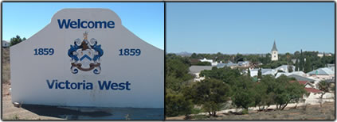

The town Victoria West was laid out on the bank of the Brakriver watercourse in 1843. It is situated on the main N12 route, at an elevation of 1300 meters. Yet the town possesses some attributes that some larger towns and cities don't have, namely tradition, a long history and an atmosphere of pride and friendliness. Victoria West is situated halfway between Cape Town and Johannesburg making it the ideal stopover point for holiday makers or businessmen on a long journey. ,

Victoria West is the seat of the Ubuntu Local Municipality within the Pixley ka Seme District Municipality. The towns in the Ubuntu Local Municipality are Victoria-West, Richmond, Loxton, Hutchinson and Merriman.

The following information of Ubuntu was reflected in the Provincial Gazette Extraordinary, dated 31 August 2010, regarding the Local Government: Municipal Structures Act (117/1998): Municipal Demarcation Board: Delimitation of municipal wards: 2011 Local Government Elections: Province Northern Cape:

